JASTRO28大会でIAEA天野事務局長挨拶

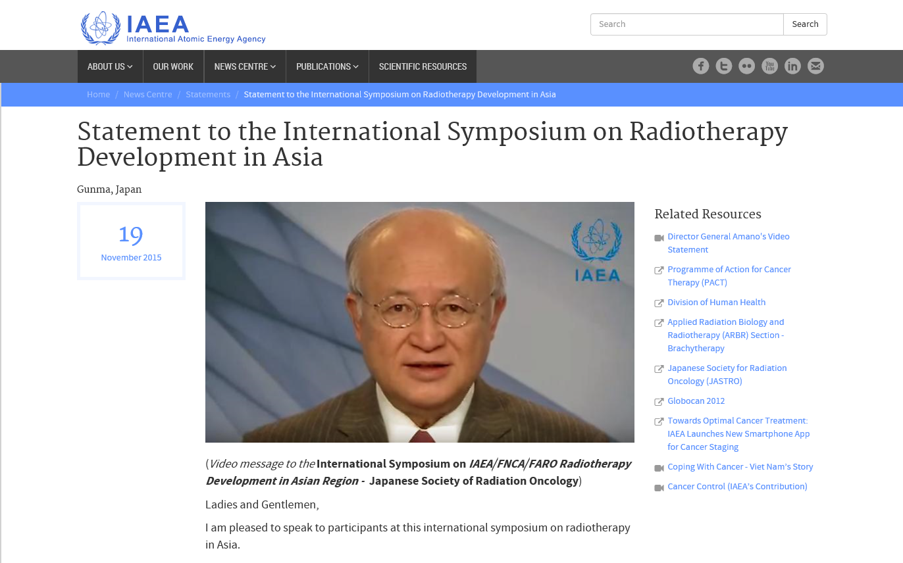

(*Video message to the* **International Symposium on *IAEA/FNCA/FARO Radiotherapy Development in Asian Region -*****Japanese Society of Radiation Oncology**)

Ladies and Gentlemen,

I am pleased to speak to participants at this international symposium on radiotherapy in Asia.

I thank Gunma University, and in particular Professor Takashi Nakano, for hosting the 28th Annual Meeting of the Japanese Society of Radiation Oncology.

Both the University and Professor Nakano are key partners for the IAEA in our human health projects in this region. I am grateful to them for their long-standing support for our work.

For more than 30 years, the IAEA has worked with Member States and international partners, through our technical cooperation programme, to improve countries’ capacity in cancer detection, diagnosis, treatment and palliative care.

Our Programme of Action for Cancer Therapy – PACT – helps countries to use limited resources efficiently and effectively. The IAEA has invested nearly 300 million euros in cancer and radiotherapy projects throughout the world.

Our mission is to transfer technologies to help save lives. We provide training for medical and technical personnel. Sometimes we help to make equipment available. We help countries build up the necessary cancer expertise so they can one day become self-sufficient.

The Asia-Pacific region is an important focus of our work. Asia has the highest burden of cancer in the world. Some 55% of global cancer deaths occur in this region and the trend is rising.

Many Asian countries have insufficient capacity to provide radiotherapy, which is a vital element of cancer control. This means patients often die of cancers which could be effectively treated if they lived in a country with well-developed cancer facilities.

This is a great human tragedy.

The IAEA is supporting 53 national cancer-related projects in the Asia-Pacific region and 18 regional projects. These cover areas such as nuclear medicine, radiopharmacy, radiation oncology and medical physics.

In Bangladesh, for example, the IAEA helped to enhance national capacity to produce bone-seeking radiopharmaceuticals used to treat many cancers at an advanced stage.

At the regional level, we have supported the development of a Cancer Staging Smartphone Application, which will significantly improve diagnosis and patient outcome.

Sri Lanka, Mongolia and Viet Nam are three of the eight countries in which we have established PACT Model Demonstration Sites.

In Sri Lanka, several PACT expert missions assessed the country’s diagnosis and treatment services. With our assistance, Sri Lanka developed a comprehensive strategic plan for cancer prevention and control and a 10-year radiotherapy action plan. It also made advances in palliative care.

Viet Nam established a National Cancer Control Steering Committee, following an IAEA recommendation, and launched a National Cancer Control Programme. We arranged training in radiation medicine for more than 30 Vietnamese health care professionals.

We also helped Viet Nam to obtain a Cobalt-60 radiotherapy unit which was donated by the Government of India. The machine has been used to treat around 40 patients a day since 2010.

In Mongolia, the IAEA has helped to secure funding from the Republic of Korea and Japan for important projects to improve radiotherapy treatment and provide professional training.

Ladies and Gentlemen,

These are all important projects which help to save many lives. But they are just the tip of a large iceberg. The need for access to effective cancer control services in developing countries remains great.

Helping to address that need has been a high priority for me since I became IAEA Director General in 2009 and it will remain a high priority.

I am very pleased that the Sustainable Development Goals adopted by world leaders in September, for the first time, recognise the huge importance of non-communicable diseases, including cancer. This gives me hope that much more will be done in the coming decades.

We at the IAEA will continue to work towards the ultimate goal of helping to ensure equitable access for *all* patients to the highest standards of cancer care, wherever they live.

I wish you every success with your important symposium.

Thank you.

19

November 2015